|  |  |  |  |  |
| --- | --- | --- | --- | --- |
| **National University of Computer and Emerging Sciences, Lahore Campus** | | | | |
| C:\Users\saif\AppData\Local\Microsoft\Windows\Temporary Internet Files\Content.Word\final design.jpg | **Course:** | **Web Programming** | **Course Code:** | **CS-406** |
| **Program:** | **BS(Computer Science)** | **Semester:** | **Fall 2017** |
| **Duration:** | **60 Minutes** | **Total Marks:** | **40** |
| **Paper Date:** | **20-Sep-17** | **Weight** | **15%** |
| **Section:** | **ALL** | **Page(s):** | **3** |
| **Exam:** | **Mid 1** | **Roll No:** |  |
| **Instruction/Notes:** | **Note: Please use the answer sheet to answer the questions.** | | | |

Question1- What is MVC design pattern? briefly describe all three parts of the MVC pattern and why they are used.

Marks 10

Question 2- Describe a servlet's life cycle. List out all the methods involved in the life cycle and the purpose of each method.

Marks 10

Question 4- What is the purpose of having a Listener in a web application. Give two examples of Listeners.

Marks 5

Question 6- As per the figure and HTML code given below write java script validation function to validate all the requirements given in red.

Marks 15

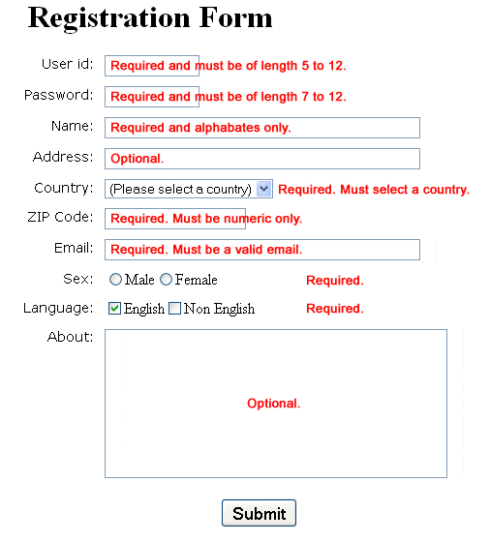

1. **<html** lang="en"**><head>**
2. **<meta** charset="utf-8"**>**
3. **<title>**JavaScript Form Validation using a sample registration form**</title>**
4. **<meta** name="keywords" content="example, JavaScript Form Validation, Sample registration form" **/>**
5. **<meta** name="description" content="This document is an example of JavaScript Form Validation using a sample registration form. " **/>**
6. **<link** rel='stylesheet' href='js-form-validation.css' type='text/css' **/>**
7. **<script** src="sample-registration-form-validation.js"**></script>**
8. **</head>**
9. **<body** onload="document.registration.userid.focus();"**>**
10. **<h1>**Registration Form**</h1>**
11. **<p>**Use tab keys to move from one input field to the next.**</p>**
12. **<form** name='registration' onSubmit="return formValidation();"**>**
13. **<ul>**
14. **<li><label** for="userid"**>**User id:**</label></li>**
15. **<li><input** type="text" name="userid" size="12" **/></li>**
16. **<li><label** for="passid"**>**Password:**</label></li>**
17. **<li><input** type="password" name="passid" size="12" **/></li>**
18. **<li><label** for="username"**>**Name:**</label></li>**
19. **<li><input** type="text" name="username" size="50" **/></li>**
20. **<li><label** for="address"**>**Address:**</label></li>**
21. **<li><input** type="text" name="address" size="50" **/></li>**
22. **<li><label** for="country"**>**Country:**</label></li>**
23. **<li><select** name="country"**>**
24. **<option** selected="" value="Default"**>**(Please select a country)**</option>**
25. **<option** value="AF"**>**Australia**</option>**
26. **<option** value="AL"**>**Canada**</option>**
27. **<option** value="PK"**>**Pakistan**</option>**
28. **<option** value="AS"**>**Russia**</option>**
29. **<option** value="AD"**>**USA**</option>**
30. **</select></li>**
31. **<li><label** for="zip"**>**ZIP Code:**</label></li>**
32. **<li><input** type="text" name="zip" **/></li>**
33. **<li><label** for="email"**>**Email:**</label></li>**
34. **<li><input** type="text" name="email" size="50" **/></li>**
35. **<li><label** id="gender"**>**Sex:**</label></li>**
36. **<li><input** type="radio" name="msex" value="Male" **/><span>**Male**</span></li>**
37. **<li><input** type="radio" name="fsex" value="Female" **/><span>**Female**</span></li>**
38. **<li><label>**Language:**</label></li>**
39. **<li><input** type="checkbox" name="en" value="en" checked **/><span>**English**</span></li>**
40. **<li><input** type="checkbox" name="nonen" value="noen" **/><span>**Non English**</span></li>**
41. **<li><label** for="desc"**>**About:**</label></li>**
42. **<li><textarea** name="desc" id="desc"**></textarea></li>**
43. **<li><input** type="submit" name="submit" value="Submit" **/></li>**
44. **</ul>**
45. **</form>**
46. **</body>**
47. **</html>**